**Q1 — TensorFlow vs PyTorch** :

Execution style: PyTorch is eager-by-default (imperative), TensorFlow historically used static graphs (TF 2.x uses eager + tf.function for graphs).

API & ecosystem: TensorFlow has strong production tools (TF Serving, TFLite), PyTorch is favored in research and is more Pythonic.

When to choose: Use PyTorch for research/rapid prototyping; choose TensorFlow if you need production deployment or mobile/embedded inference.

**Q2 — Two use cases for Jupyter Notebooks:**

Exploratory data analysis and visualization.

Demonstrating experiments and reproducible tutorials or reports.

**Q3 — spaCy vs basic string ops:**

spaCy provides tokenization, POS tagging, dependency parsing, named entity recognition, and efficient pipelines; string ops are brittle (no linguistic structure) and fail on edge cases.

Comparative analysis Scikit-learn vs TensorFlow:

Target applications: scikit-learn = classical ML (SVMs, trees), TensorFlow = deep learning / large neural networks.

Ease for beginners: scikit-learn generally easier for classic models; TensorFlow has higher initial learning curve but strong high-level APIs (Keras).

Community support: both large — TensorFlow has wide industry support, scikit-learn is staple for ML education and applied tasks.

Ethics & Troubleshooting guidance (what to grade)

Bias identification examples:

MNIST: digit styles biased by handwriting demographics (age, region) — mitigation: augment data, curate diverse datasets, test performance across subgroups.

Amazon reviews: product popularity bias (popular brands have more data), review sentiment skewed by selection bias — mitigation: re-sampling, fairness metrics, per-group evaluation.

Tools & mitigation:

TensorFlow Fairness Indicators or sklearn metrics per subgroup to check disparate performance.

spaCy rule-based systems to catch rare categories or flagged terms.

Debugging task: Provide a small buggy TF snippet to students (dimension mismatch or wrong loss) and ask them to fix; grade on clarity of fix.

#### ****Task 1: Classical ML with Scikit-learn****

📈 Evaluation Results:

Accuracy: 1.000

Precision: 1.000

Recall: 1.000

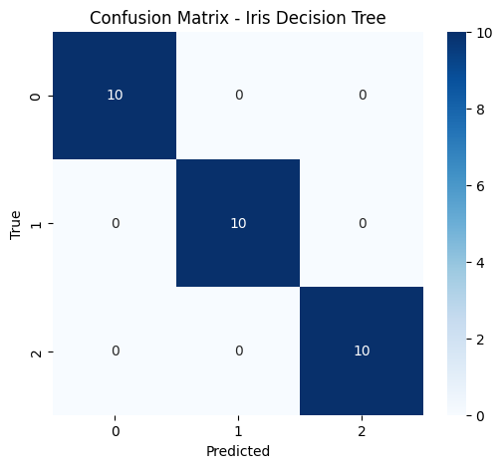

#### ****Task 2: Deep Learning with TensorFlow/PyTorch****

✅ Test Accuracy: 0.9916

Test Loss: 0.0253

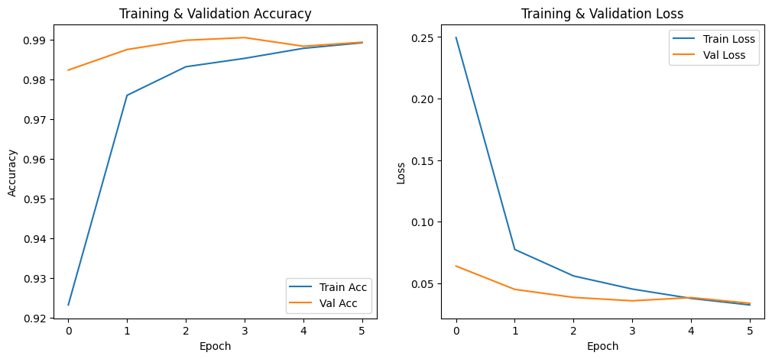

#### ****Task 3: NLP with spaCy****

Streaming output truncated to the last 5000 lines.

ENTITIES: [('BUY', 'ORG'), ('GE', 'ORG')]

------------------------------------------------------------

REVIEW: Brilliant but frightening: This book should be a must read in economics, biology, civics or any globally focused course in late high school or college. Definitely not the kind of book one reads when one is having trouble sleeping. In fact - I had to stop reading it before bed. Sobering, thought-provoking, life changing material.

ENTITIES: [('one', 'CARDINAL')]

------------------------------------------------------------

REVIEW: Decent but not the best.: I've had this program. I'm using Click N Burn Pro now and it is as easy to use, less expensive and has the same features. Save some money and go with Click N Burn.

ENTITIES: []

------------------------------------------------------------

REVIEW: How Its Done:An Invitation to Social Research, 3rd edition: I somehow got the wrong edition. I am pretty sure I selected the correct edition, but it wasn't until I got to class that I noted the error. Next time I will be sure to double and triple check my order.

ENTITIES: [('3rd', 'ORDINAL')]

------------------------------------------------------------

REVIEW: Good but not excellent as I had hoped: I guess I was hoping for the subtlety and finesse that I have come to expect from Greenwood Cooper productions. The contents of this DVD were much more overt. I also purchased Pools of Desire, also a Greenwood Cooper production, and this DVD was right on target with what I have come to expect from this company.

ENTITIES: [('Greenwood Cooper', 'ORG'), ('Pools of Desire', 'ORG'), ('Greenwood Cooper', 'WORK_OF_ART')]

------------------------------------------------------------